JAVASCRIPT

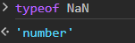

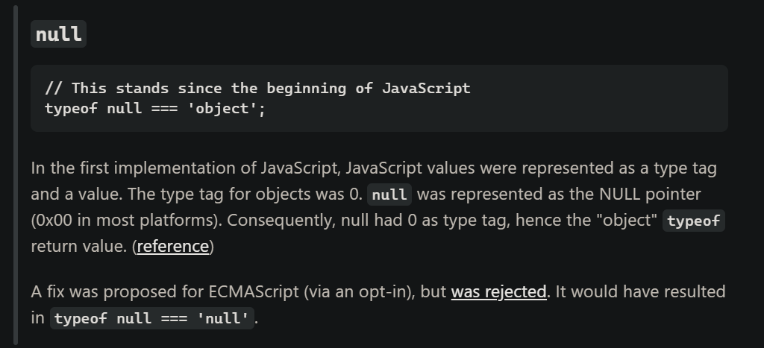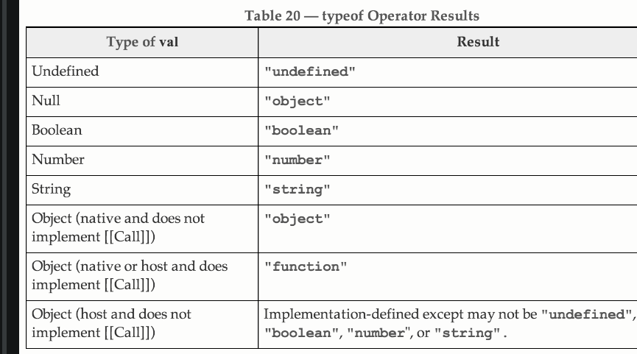

at the time of invocation, ekhada Function jya Object chi property aahe (at that time), tya object la refer krto to **this** keyword

The silly way to understand the “this” keyword is, whenever the function is invoked, check the object before the dot. The value of this . keyword will always be the object before the dot.

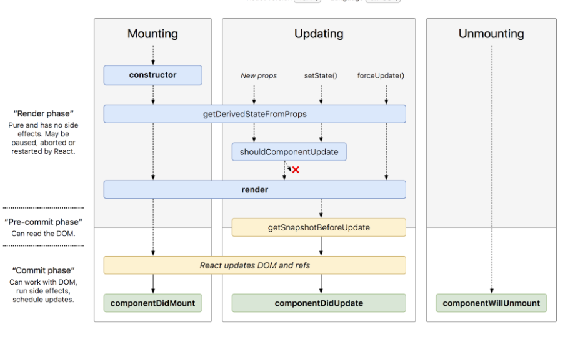

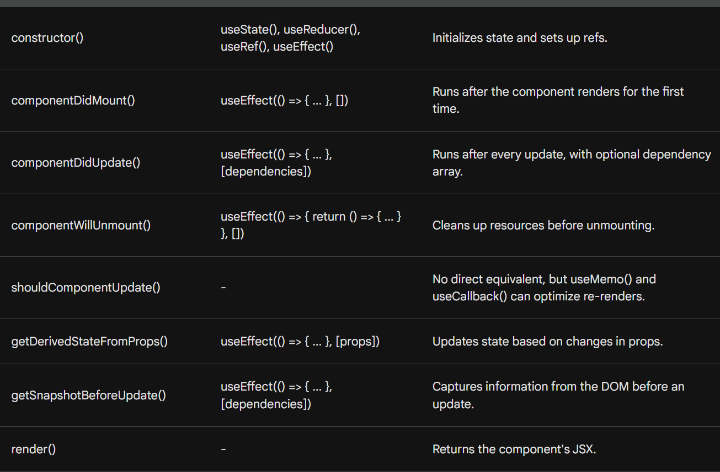

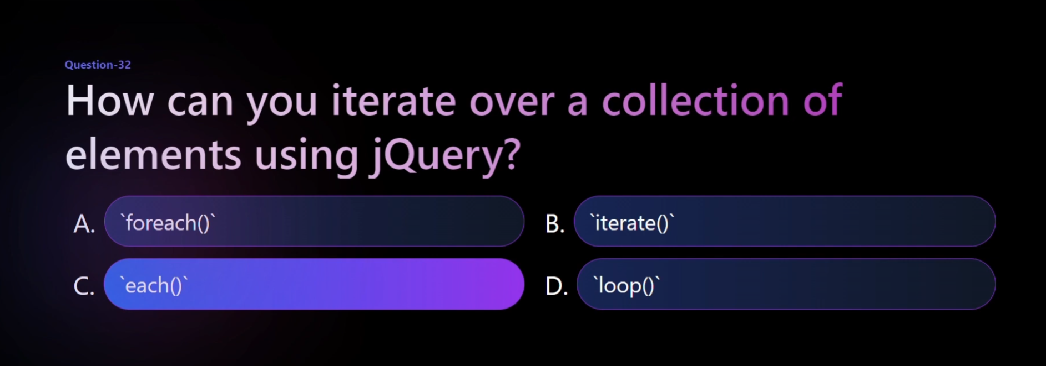

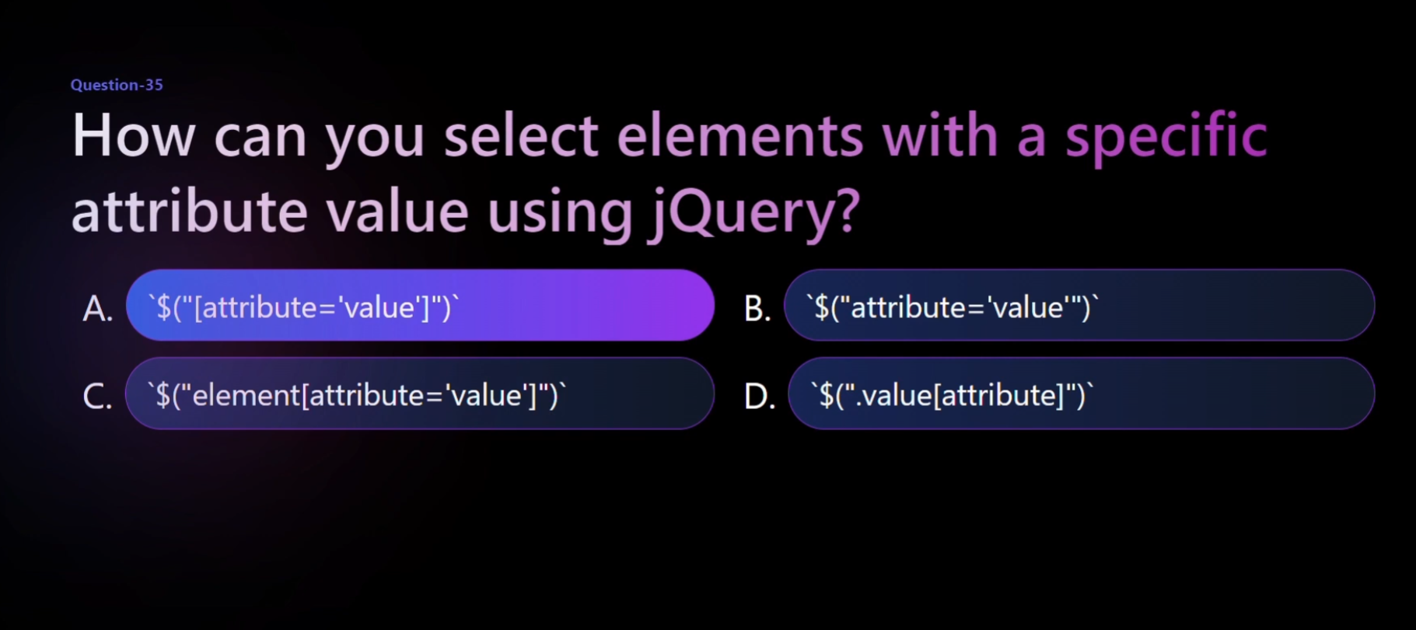

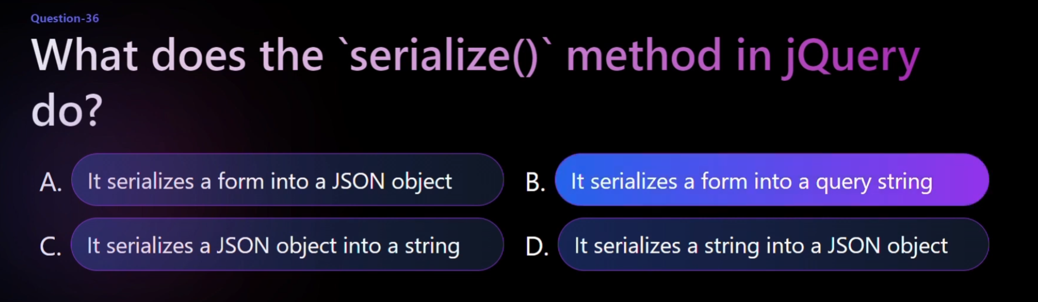

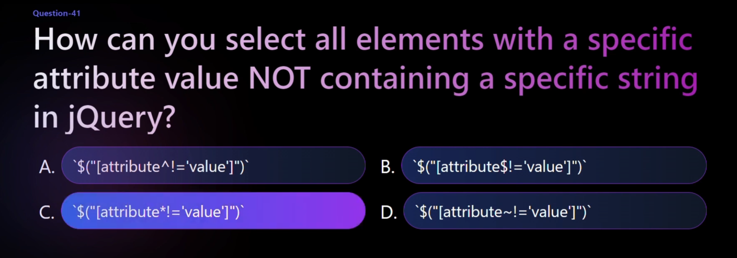

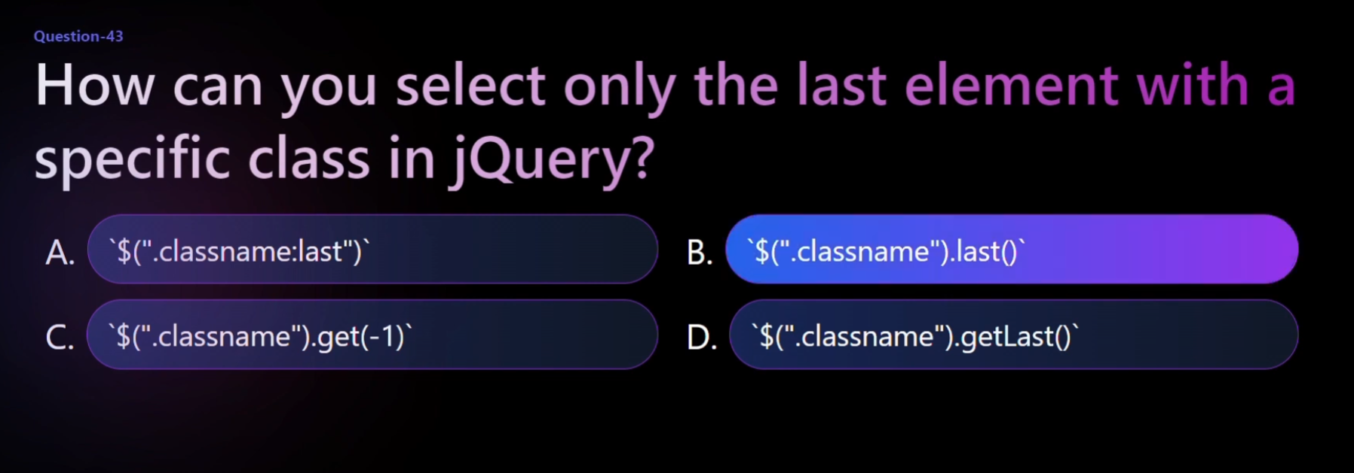

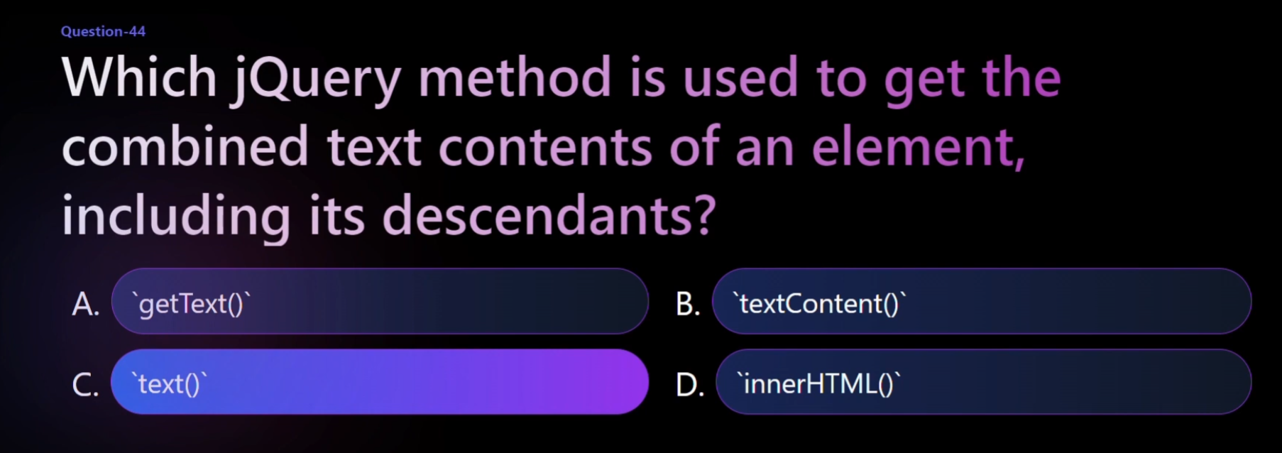

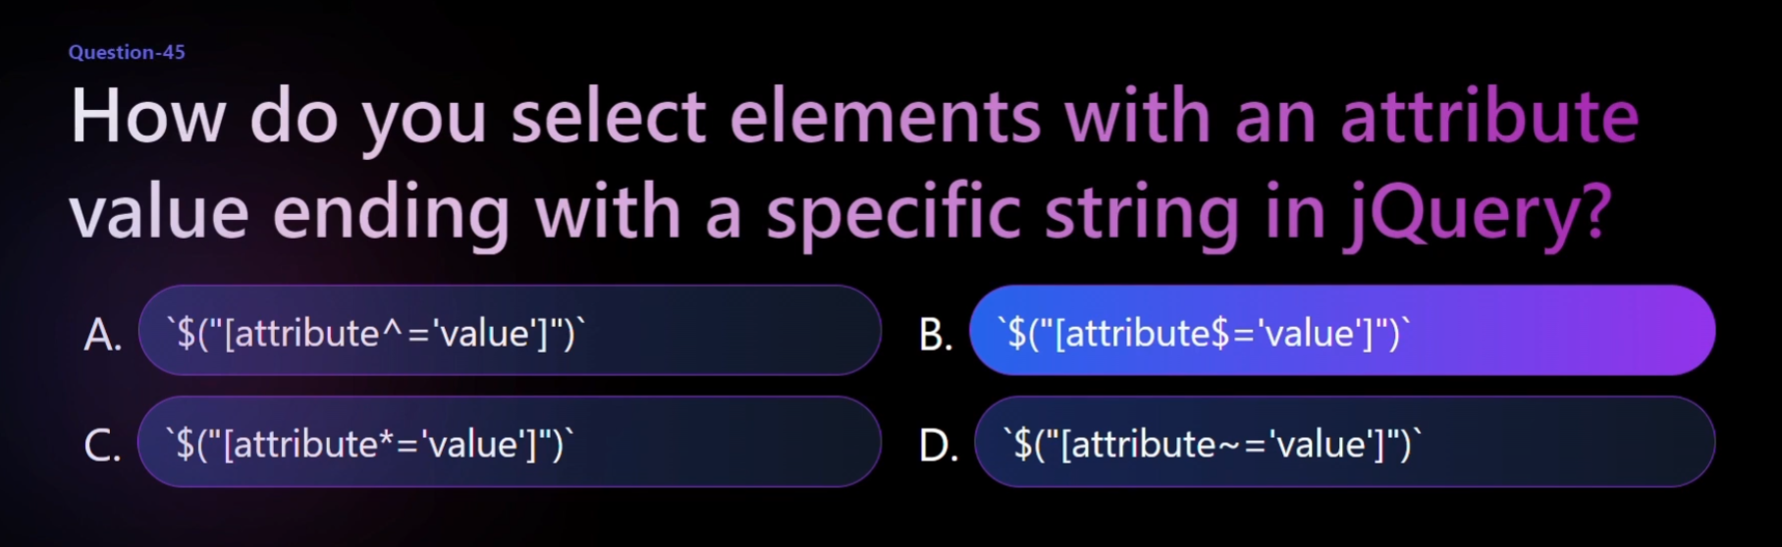

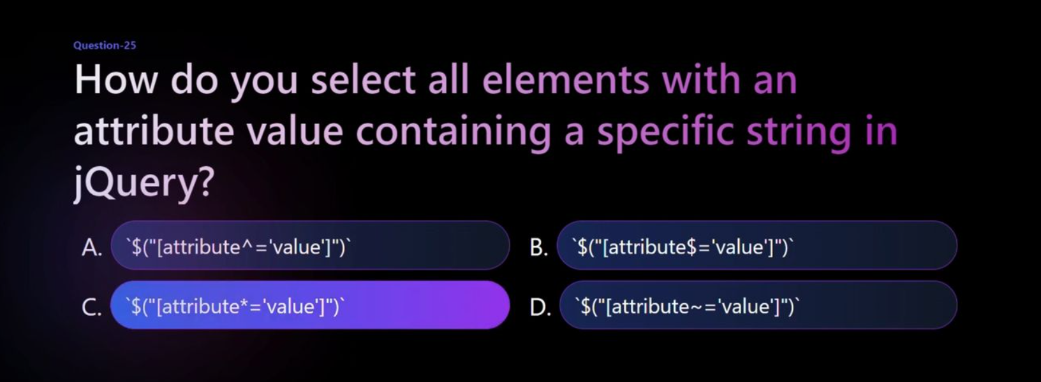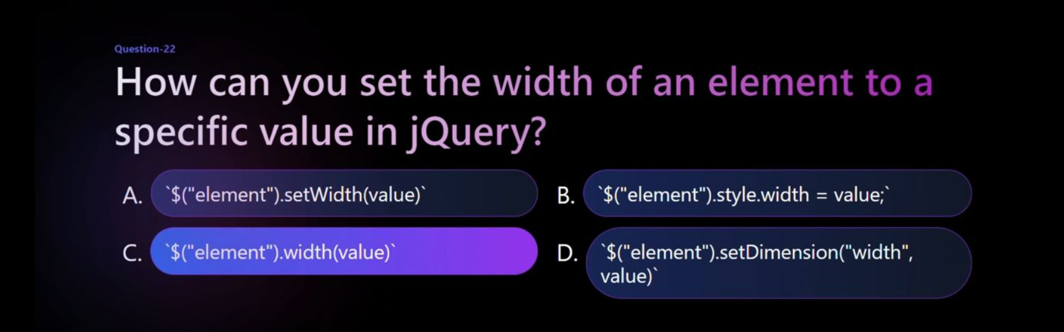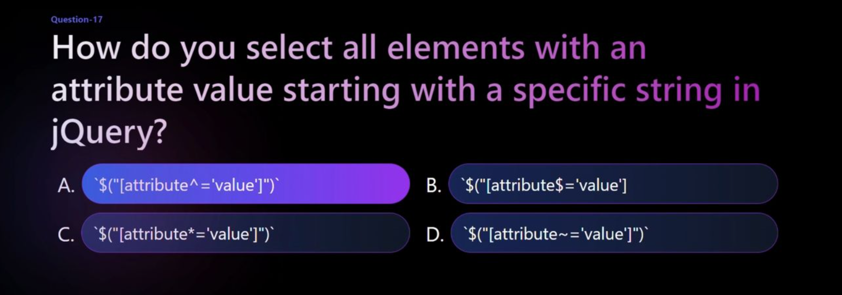

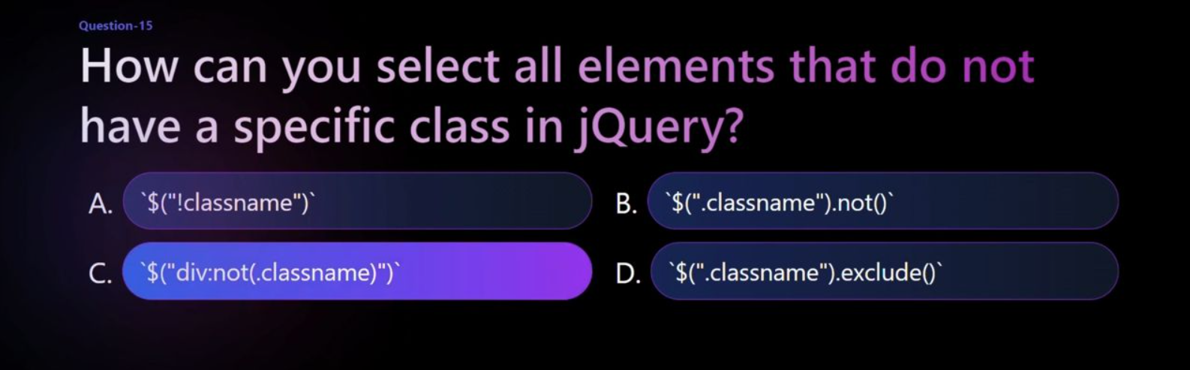

B above ans

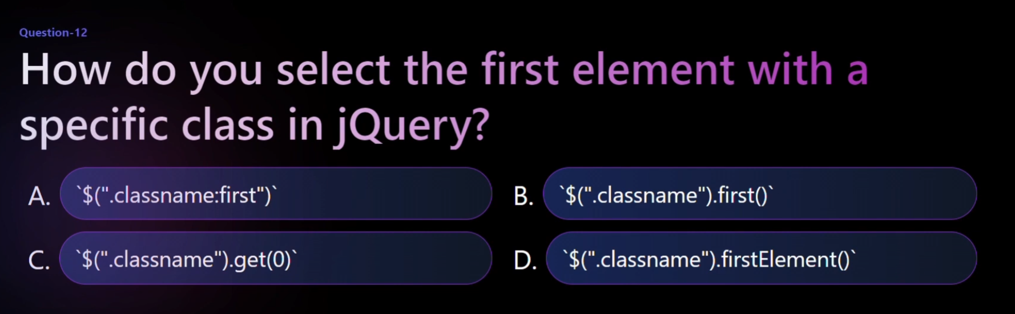

C above



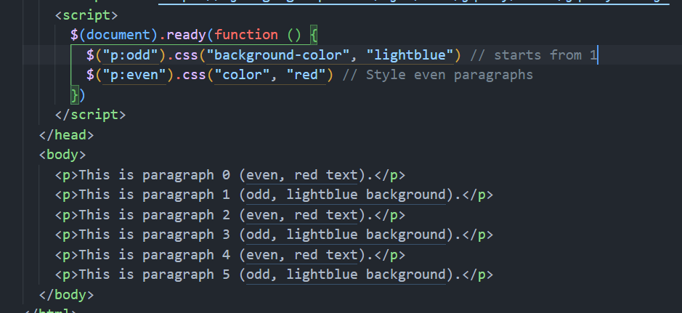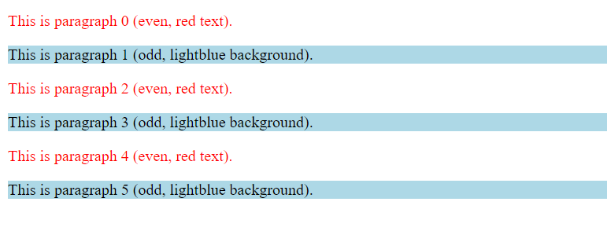

Question paper cdac

______ variable in expressjs helps to get current directory name

ChatGPT

In Express.js, the __dirname variable is used to get the current directory name. It represents the name of the directory that contains the JavaScript source code file.

In Express.js, besides __dirname, there are other commonly used variables and objects. Here are a few:

__filename:

Represents the filename of the code being executed. It provides the full path to the current file.

req (Request Object):

Represents the HTTP request and has properties for the request query parameters, body, headers, etc.

res (Response Object):

Represents the HTTP response and is used to send data back to the client.

process:

Global object that provides information about the current Node.js process.

console.log(process.env.PORT); // Access environment variables

User

Which of the following will start nodejs server at port 3000 using expressjs?

If var app=require(“express”);

Options:

* app. listen(8080);
* app.listen(3000); //ans
* lt is compulsory to add http module in the code and then use http.start(3000)
* None of the above

Why not option 3

ChatGPT

Option 3 suggests that it is compulsory to add the HTTP module in the code and then use http.start(3000). However, this is not accurate when using Express.js. In Express.js, the listen method is directly called on the Express application (app) to start the server.

Therefore, for an Express.js server, you typically use app.listen(port) to start the server, and there is no compulsory need to use the HTTP module separately for this purpose.

User

If in Node.js we have written a module name myModule.js in current folder, then how to add it in another .js file using require?

ChatGPT

To add a module named myModule.js from the current folder in another .js file using require, you can follow these steps:

Make sure that both files are in the same directory.

Use the require statement to import the module in your second file.

For example, if your folder structure is like this:

javascript

Copy code

// mainFile.js

**const myModule = require('./myModule.js');**

User

Write selector which will select only first li element of only unordered list?

ChatGPT

Certainly! In jQuery, you can achieve this with the :first-child and :first-of-type selectors as well. Here's an example:

<body>

<ul>

<li>First List - First Item</li>

<li>First List - Second Item</li>

</ul>

<ul>

<li>Second List - First Item</li>

<li>Second List - Second Item</li>

</ul>

<!-- jQuery script to select the first li of the first ul -->

<script>

$(document).ready(function(){

**$('ul:first-of-type li:first-child').css('color', 'blue');**

});

</script>

</body>

</html>

This jQuery script will change the text color of the first li element of the first unordered list to blue. Adjust the styles and selectors according to your requirements.

User

Which of the following code will assign click event for given tag?

This is para

Options:

* ﻿﻿$(?#myclass?).click(myfunction);
* ﻿﻿$(?#myclass?).onclick(myfunction);
* ﻿﻿$(?.myclass?).click(myfunction);
* $(? myclass?).onclick(myfunction);

ChatGPT

The correct option to assign a click event for a given tag using jQuery is:

$('.myclass').click(myfunction);

So, the correct option is:

$(?.myclass?).click(myfunction);

User

var obj={name:” Rajan”, phone.

_number: 11111};

var obj1={desg:?CEO?,

dept: ?computer?}

Which of the following statement will make obj1 as child and obj as parent using inheritance?

Options:

* obj.__proto__ =obj1;
* **obj1.__proto__ =obj; //ans**
* obj1[parent]=obj;

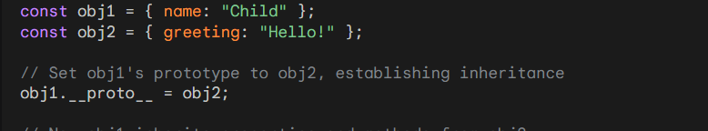

User

You have an application which enables a user to enter a URL. The URL may contain spaces which are not supported in requests which are sent from browsers.

You need to solve this

problem by replacing the space by a special symbol like %. How can this be achieved?

Options:

**using decode method**

Ousing replace method using escape method using encode method

ChatGPT

To replace spaces with a special symbol like % in a URL, you can use the encodeURIComponent method. This method replaces spaces and other special characters with their respective percent-encoded values.

Here's an example:

function encodeURL() {

var userInput = document.getElementById("urlInput").value;

var encodedURL = encodeURIComponent(userInput);

alert("Encoded URL: " + encodedURL);

}

</script>

In this example, when the user enters a URL with spaces and clicks the "Encode URL" button, the JavaScript function encodeURL is called. It uses encodeURIComponent to replace spaces and other special characters in the input URL, and then displays the encoded URL in an alert.

So, the correct option is:

using encode method

User

Where did we use encode method above

ChatGPT

I apologize for the confusion. The correct option for the scenario described is:

using encodeURIComponent method

In the example provided, the encodeURL function uses encodeURIComponent to encode the user input.

User

How many life phase stages are there in react life cycle?

ChatGPT

In React, there are three main life cycle phases:

1. **Mounting**: This phase involves the creation of a component and inserting it into the DOM.

constructor()

static getDerivedStateFromProps()

render()

**componentDidMount**()

1. **Updating**: This phase occurs when a component is being re-rendered as a result of changes to either its props or state.

static getDerivedStateFromProps()

**shouldComponentUpdate**()

render()

getSnapshotBeforeUpdate()

componentDidUpdate()

1. **Unmounting**: This phase involves removing the component from the DOM.

componentWillUnmount()

Additionally, there is a separate set of life cycle methods related to error handling:

Error Handling:

static getDerivedStateFromError()

componentDidCatch()

It's worth noting that some life cycle methods are considered legacy and might be deprecated in future React versions. The new React Hooks provide an alternative approach to handling component state and side effects.

AJAX

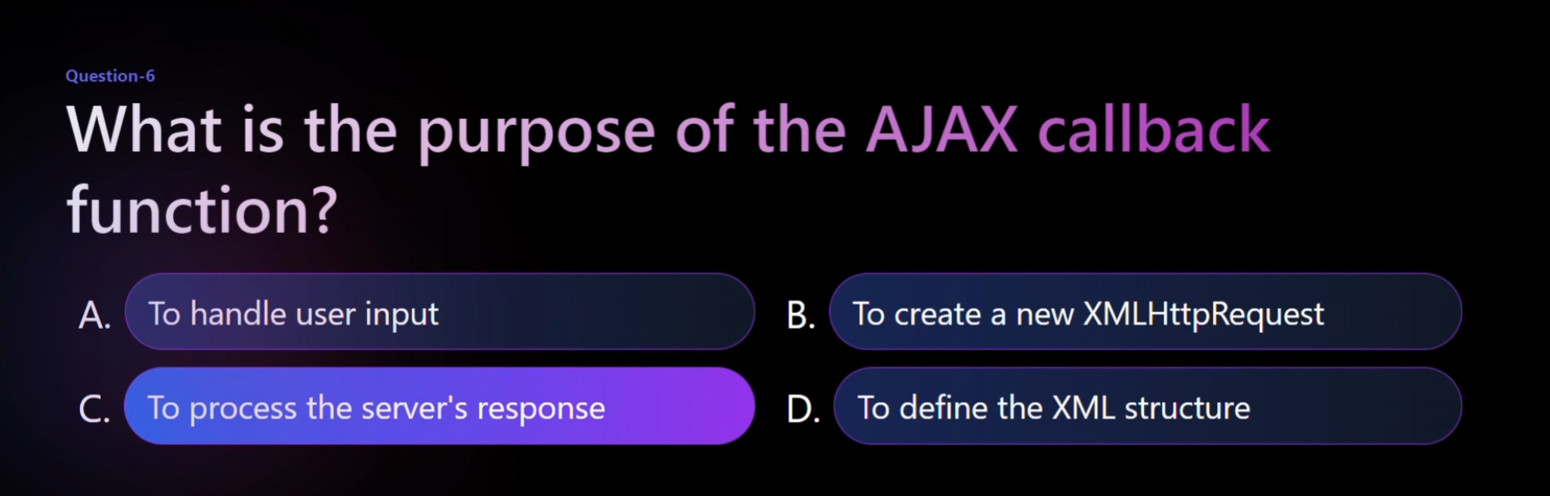

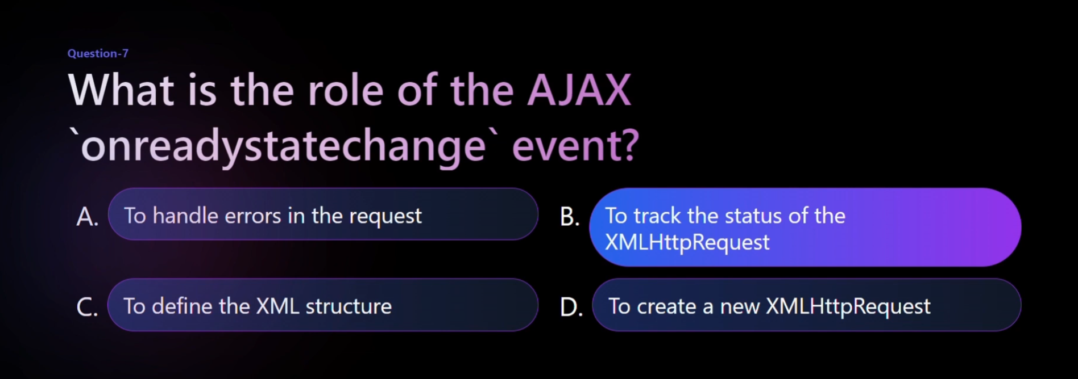

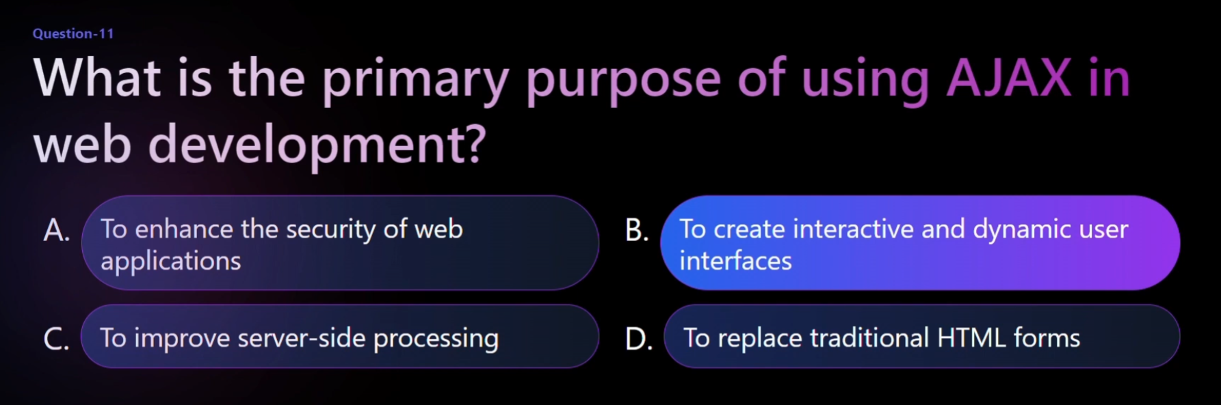

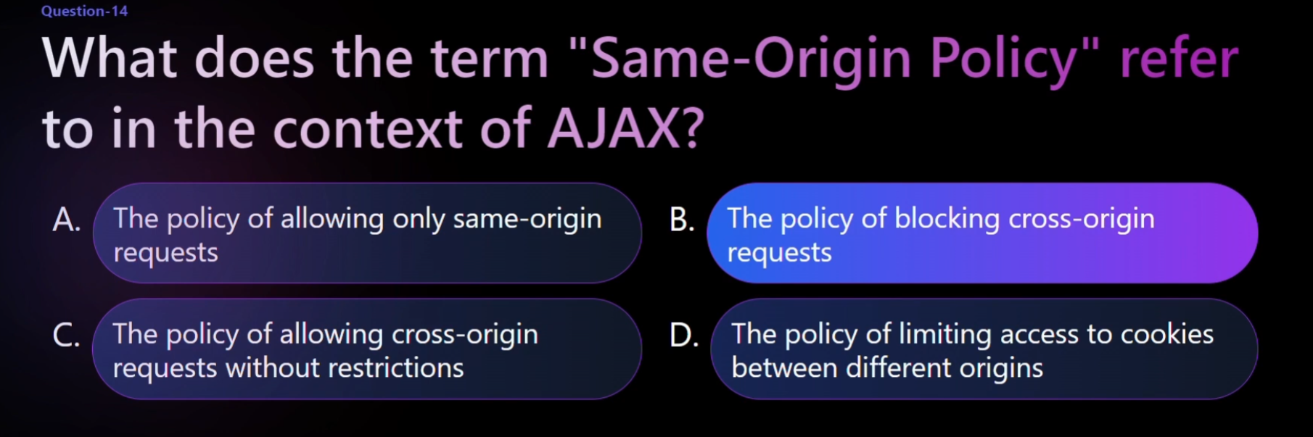

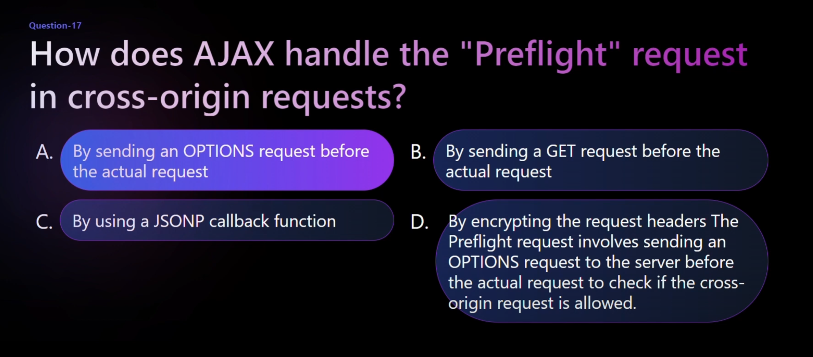

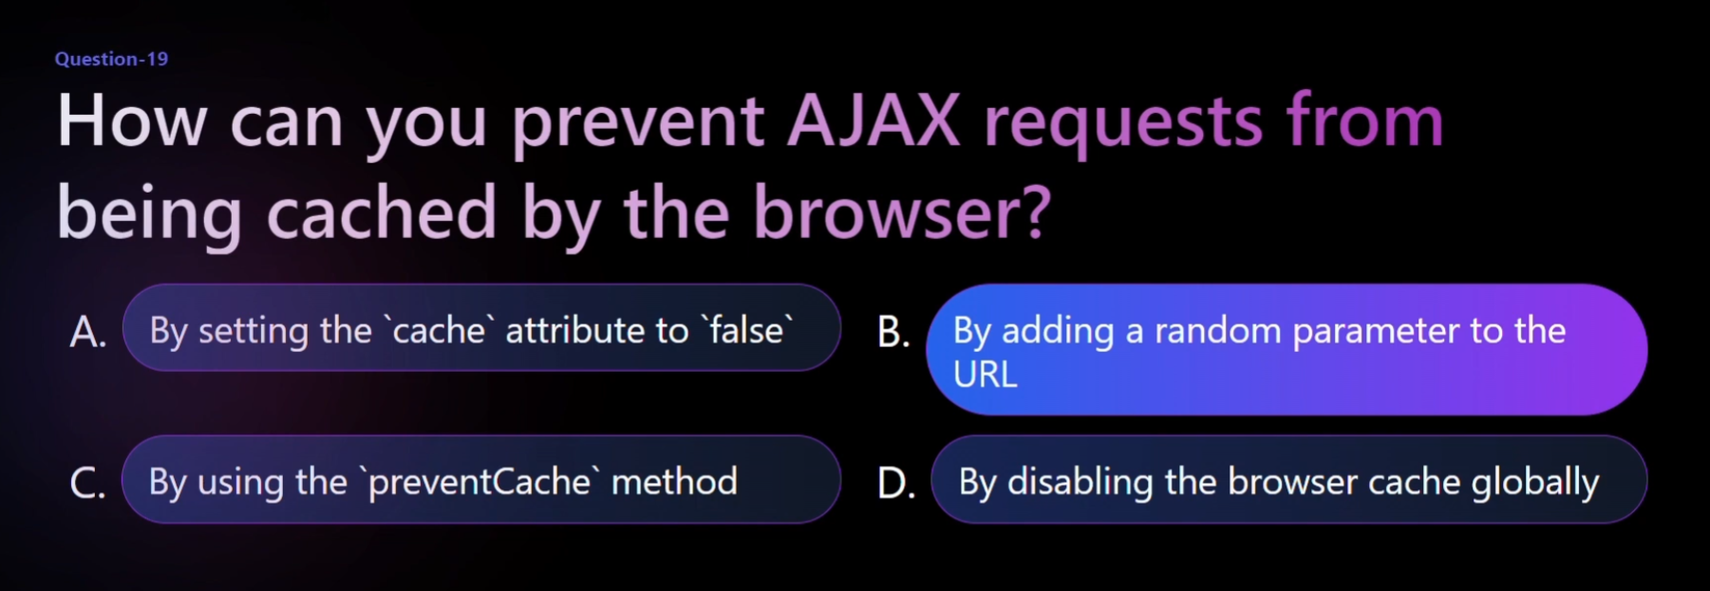

Express JS

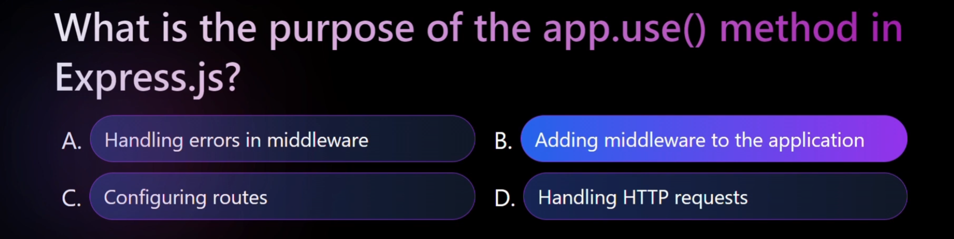

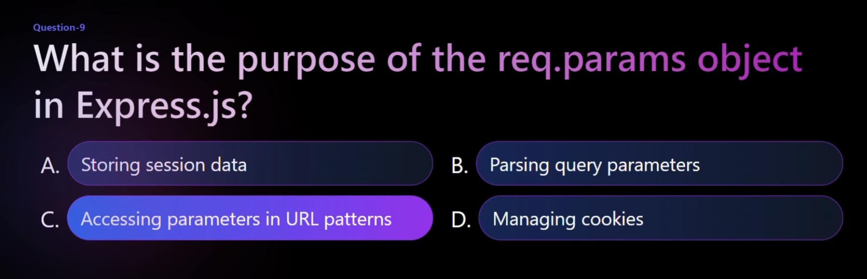

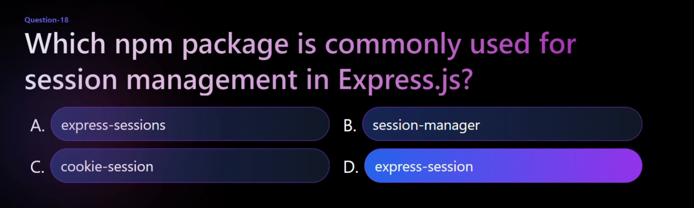

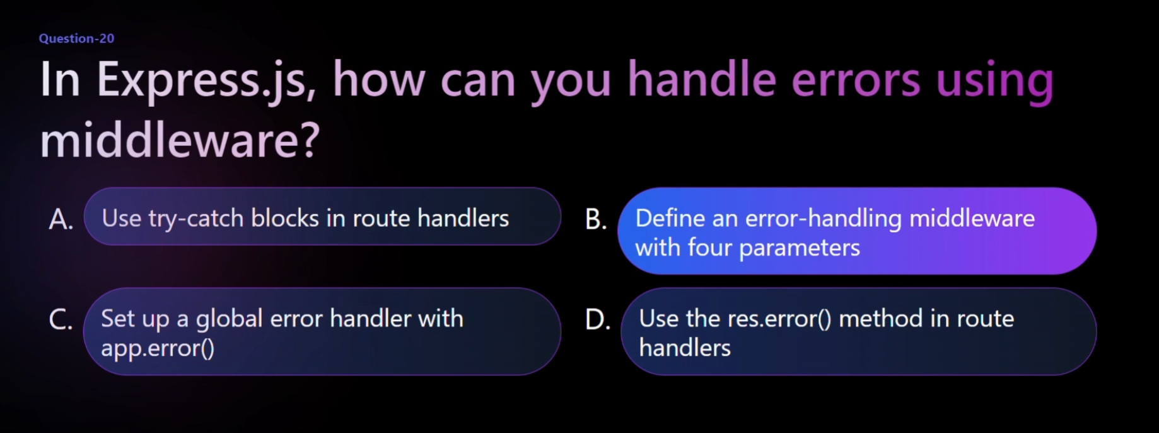

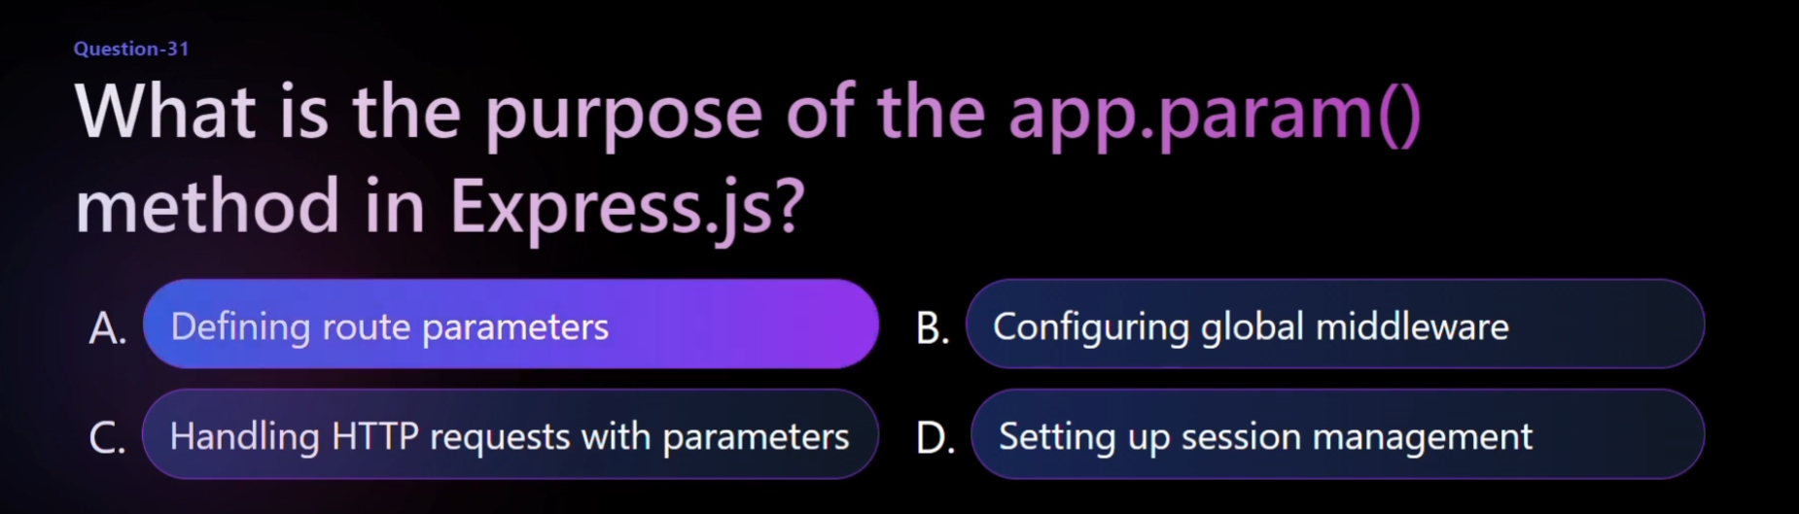

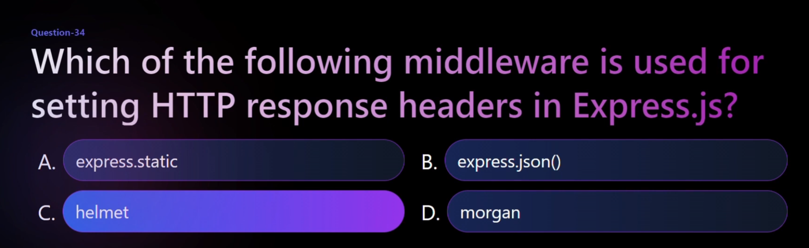

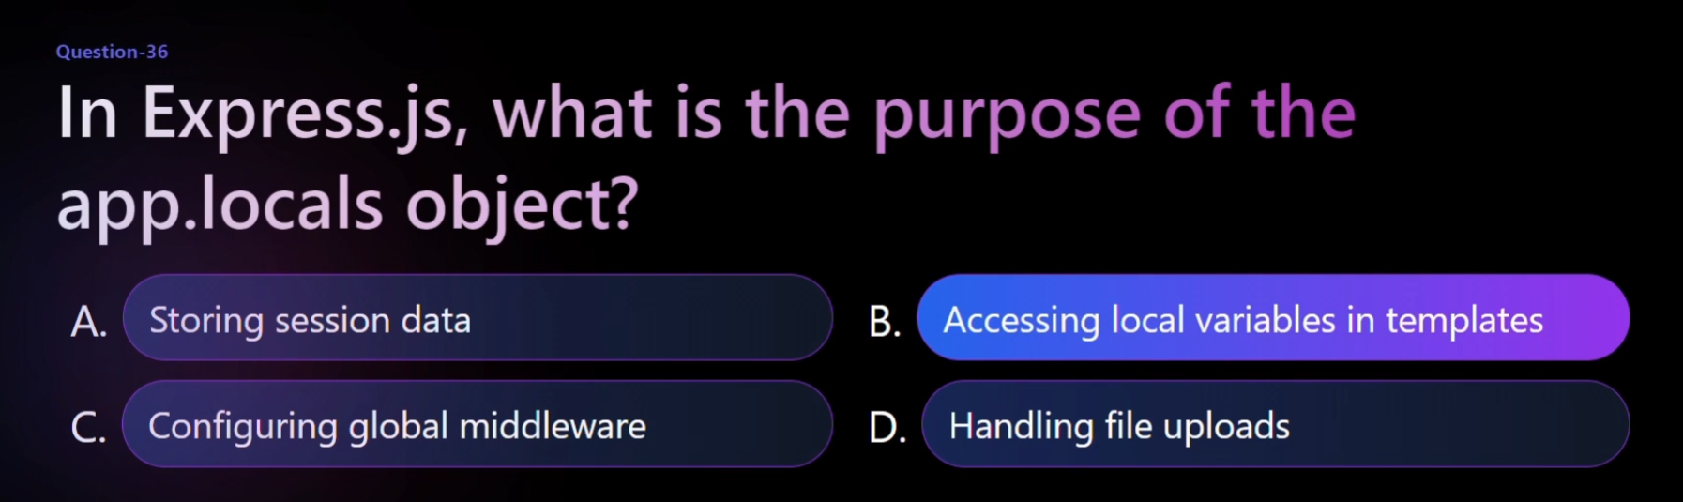

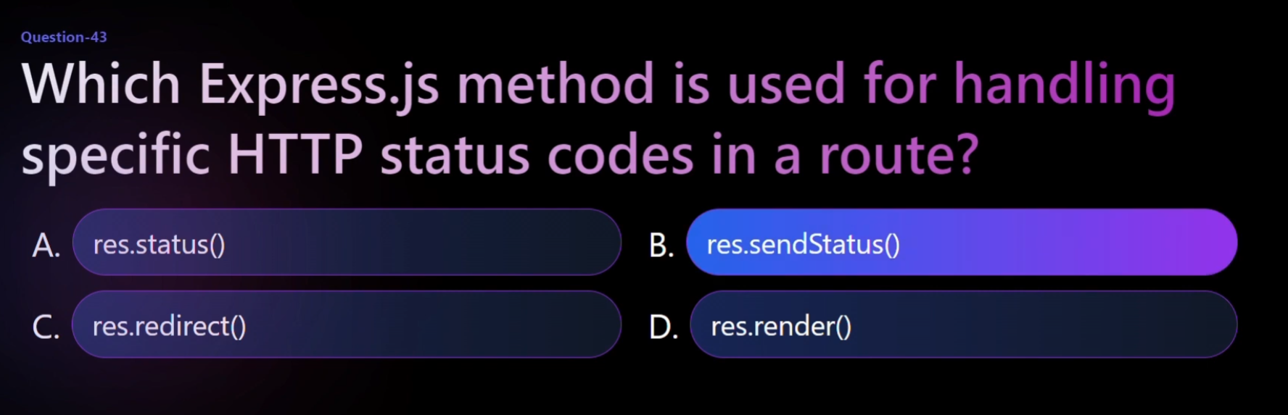

And req.query used for query paramaters

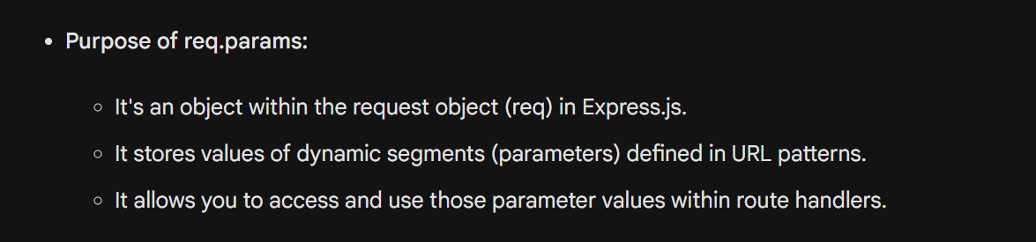

Express.js provides a powerful feature called middleware, which allows you to intercept and modify requests and responses throughout their processing cycle. Here's a list of common Express.js middlewares with their uses:

Built-in Middlewares:

* express.static: Serves static files (images, CSS, JS) from a specified directory.
* express.json: Parses JSON payloads received in the request body.
* express.urlencoded: Parses URL-encoded payloads received in the request body.
* helmet: Provides various security headers to protect your application.
* morgan: Logs HTTP requests and responses for debugging and monitoring purposes.

Common Third-party Middlewares:

* cors: Enables Cross-Origin Resource Sharing (CORS) to allow requests from other domains.
* connect-session: Creates and manages user sessions.
* passport: Implements authentication and authorization strategies.
* compression: Compresses responses to reduce bandwidth usage.
* body-parser: Parses various payloads like JSON, text, and URL-encoded.
* multer: Handles multipart form data with file uploads.
* validator: Validates incoming data against user-defined rules.

Application-level Middlewares:

* Logging middleware: Logs every request and response to a file or database.
* Error handling middleware: Catches and handles errors occurring during request processing.
* Authentication middleware: Checks if a user is authenticated before accessing specific routes.
* Authorization middleware: Checks if a user has permission to perform a specific action.

Router-level Middlewares:

* Prefix middleware: Adds a prefix to all routes defined within a specific router.
* Validation middleware: Validates incoming data specifically for routes within a router.
* Authorization middleware: Limits access to certain routes within a router based on user permissions.

Remember: Selecting the right middleware depends on your specific needs and application requirements. It's best to choose a minimal set of middlewares to avoid performance overhead and maintain clean code.

Here are some of the essential Express.js methods for defining routes and handling requests:

App-level Methods:

* app.get(path, callback): Defines a route for GET requests at the specified path.
* app.post(path, callback): Defines a route for POST requests.
* app.put(path, callback): Defines a route for PUT requests.
* app.delete(path, callback): Defines a route for DELETE requests.
* app.patch(path, callback): Defines a route for PATCH requests.
* app.all(path, callback): Defines a route that matches all HTTP methods.
* app.use(path, callback): Mounts middleware at a specific path or globally.
* app.listen(port, [hostname], [callback]): Starts the server and listens for incoming connections on the specified port.

Request Object (req) Properties:

* req.params: Contains parameters from the URL path (for dynamic routes).
* req.query: Contains query parameters from the URL.
* req.body: Contains the parsed request body (if applicable).
* req.headers: Contains HTTP headers from the request.
* req.method: Contains the HTTP method of the request (GET, POST, etc.).
* req.url: Contains the full URL of the request.

Response Object (res) Methods:

* res.send(data): Sends a response with the specified data as text.
* res.json(data): Sends a JSON response with the specified data.
* res.status(code): Sets the HTTP status code of the response.
* res.redirect(url): Redirects the client to a different URL.
* res.render(view, [data]): Renders a view template with optional data.

Router Object Methods:

* router.get(path, callback): Same as app.get, but for routes defined within a router.
* router.post(path, callback): Same as app.post, but for routes within a router.
* router.put(path, callback): Same as app.put, but for routes within a router.
* router.delete(path, callback): Same as app.delete, but for routes within a router.
* router.patch(path, callback): Same as app.patch, but for routes within a router.
* router.all(path, callback): Same as app.all, but for routes within a router.
* router.use(path, callback): Mounts middleware for routes within a router.

Additional Methods:

* express.static(path): Serves static files from the specified directory.
* express.json(): Parses incoming JSON data and populates req.body.
* express.urlencoded(): Parses incoming URL-encoded data and populates req.body.

These methods provide a foundation for building web applications with Express.js. By combining these methods with middleware and other features, you can create dynamic and scalable web APIs and servers.

Node JS

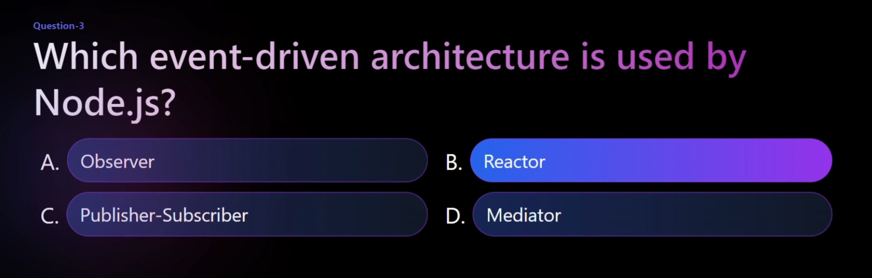

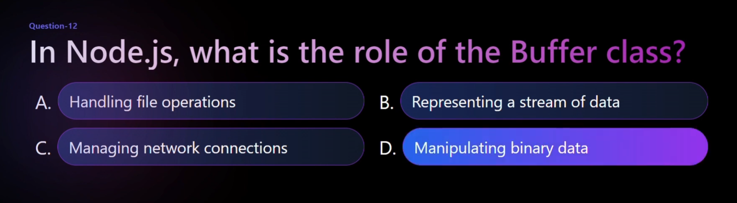

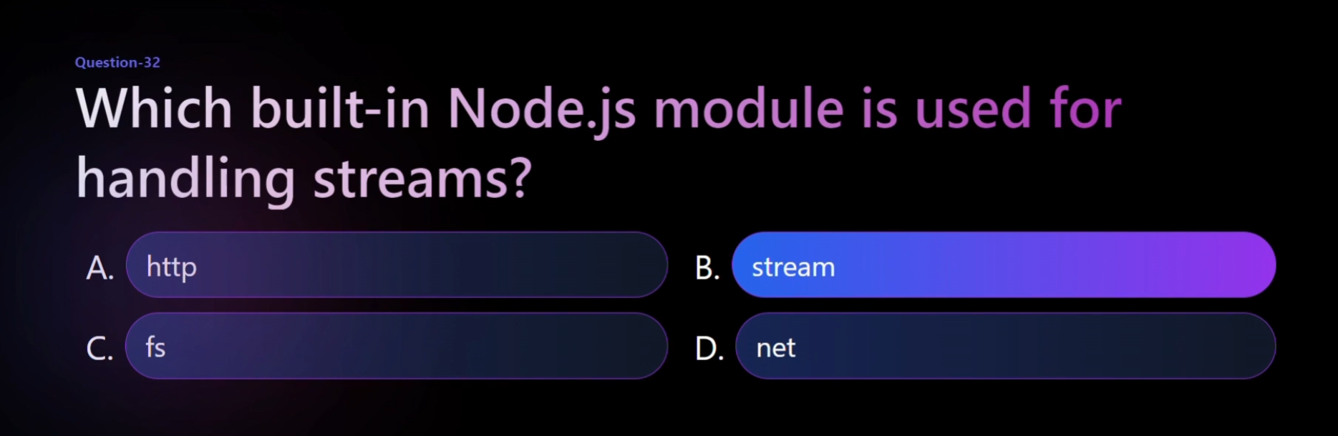

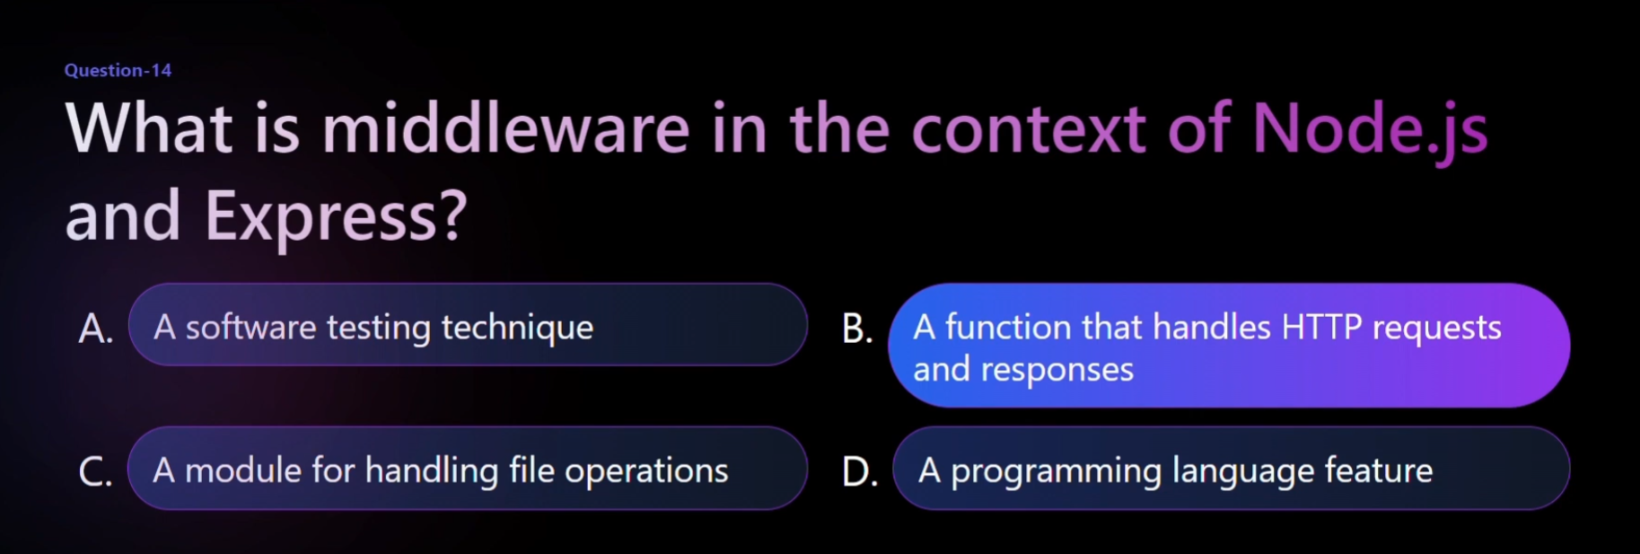

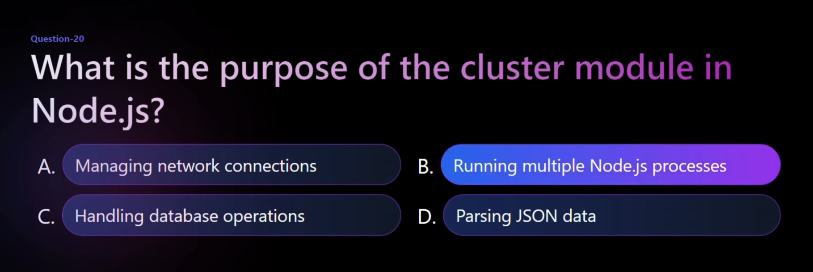

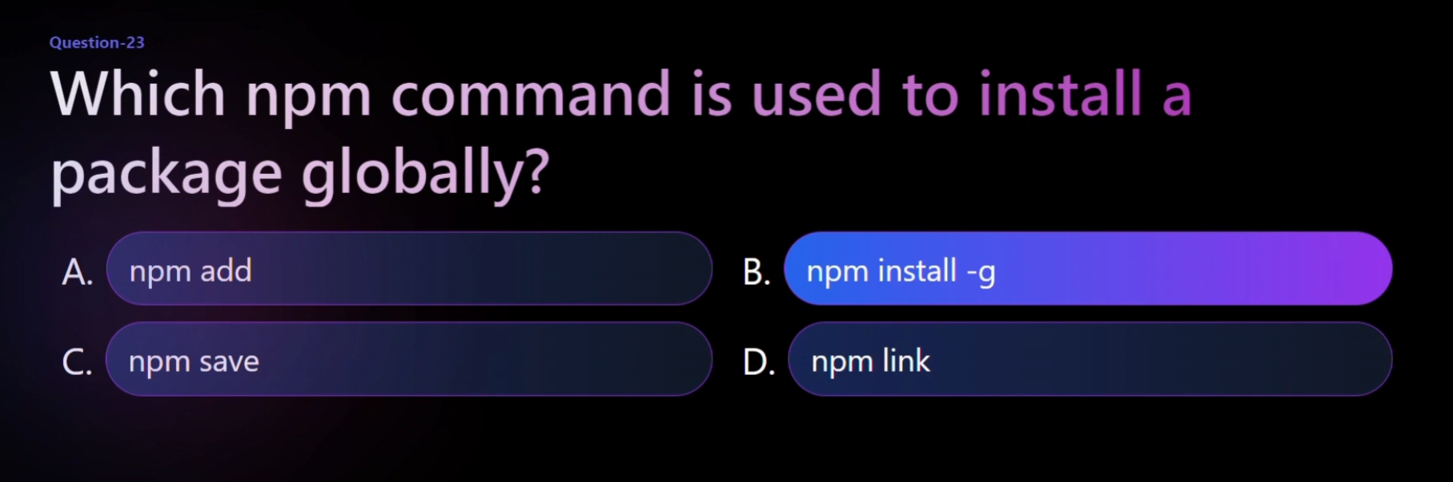

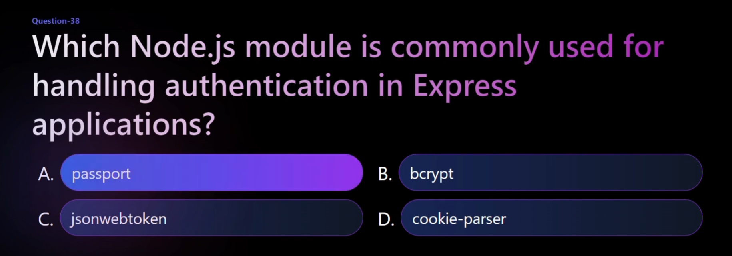

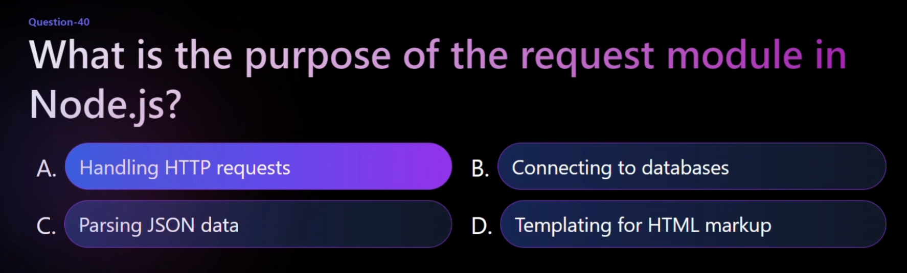

HTML: Tim Berners-Lee:

CSS: Håkon Wium Lie

Bootstrap: Mark Otto and Jacob Thornton: Twitter,

JavaScript: Brendan Eich, a Mozilla developer,

jQuery: John Resig

Express: TJ Holowaychuk

Node.js: Ryan Dahl:

React:Jordan Walke: Jordan Walke, a Facebook software engineer,